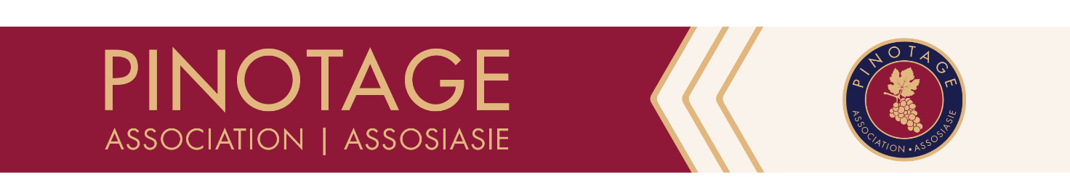

REGISTRATION FORM | REGISTRASIEVORM

ANNUAL GENERAL MEETING | ALGEMENE JAARVERGADERING
6 June 2023 @ The Palm Terrace, Neethlingshof, Stellenbosch, 09h00 – 13h30

- CLOSING DATE FOR REGISTRATION AND RECEIPT OF PAYMENT: 31 May 2023.
SLUITINGSDATUM VIR REGISTRASIE EN ONTVANGS VAN BETALING: 31 Mei 2023.
Registration is compulsory and will take place upon receipt of completed registration form.
Registrasie is verpligtend en sal geskied by ontvangs van volledig voltooide aansoekvorm.

- Cost:
- Members: R150.00 (membership must be paid by 31 May 2023 to qualify.)
Lede: R150.00 (lidmaatskap moet teen 31 May 2023 betaal wees om te kwalifiseer.)

- Non-members: R300 pp
- Nie-lede: R300 pp
Invoice will be issued upon receipt of payment./ Faktuur sal uitgereik word met ontvangs van betaling.

Cellar or company
Kelder of maatskappy
Name / Name |  | Member  Lid | Yes  Ja |  | No  Nee
Name / Name |  | Member  Lid | Yes  Ja |  | No  Nee
Name / Name |  | Member  Lid | Yes  Ja |  | No  Nee
Address / Adres
E-mail / E-pos
Tel. |  | Cell no.  Selnr.
Invoice made out to
Faktuur uitgemaak aan
______________________ ________________
Signature / Handtekening Date / Datum
PAYMENT DETAILS | BETALINGSBESONDERHEDE
Beneficiary | Begunstigde: Pinotage Association/Association
Bank: ABSA
Account no. | Rekeningnr. 410216949
Branch code | Takkode:: 632005
Ref. | Verw.: Name of cellar | Naam van kelder
CONTACT PERSON | KONTAKPERSOON
Leilanie Zietsman | T.: 021 863 1599; E-mail/pos: info@pinotage.co.za

